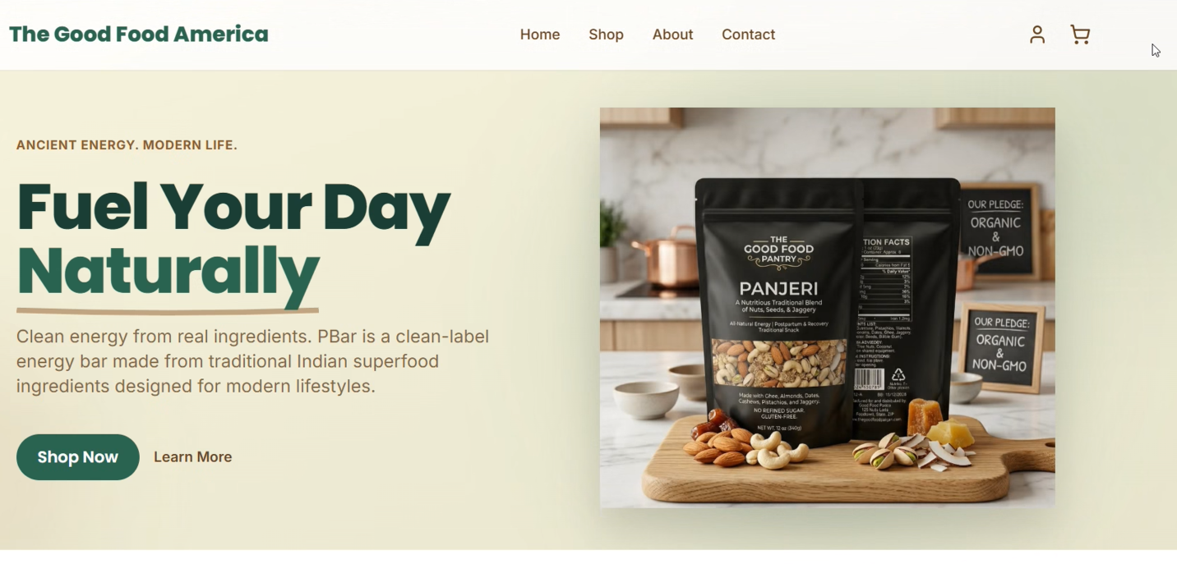
Clean energy powered by real ingredients. Panjeri goes beyond your everyday trail mix, delivering wholesome nutrition to support year-round wellness. Rooted in tradition and valued for promoting bone and muscle strength, Panjeri is a nourishing upgrade to any diet.
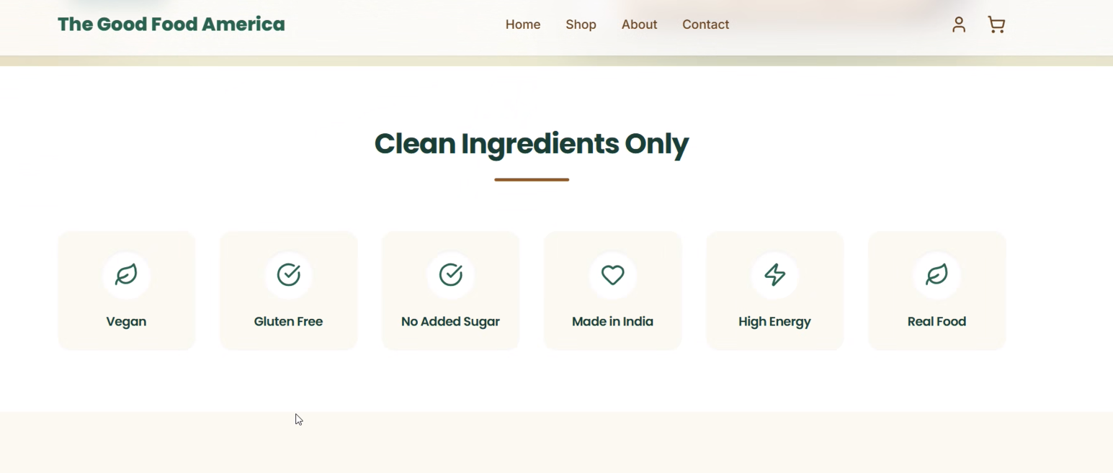
This part goes below the shop products below

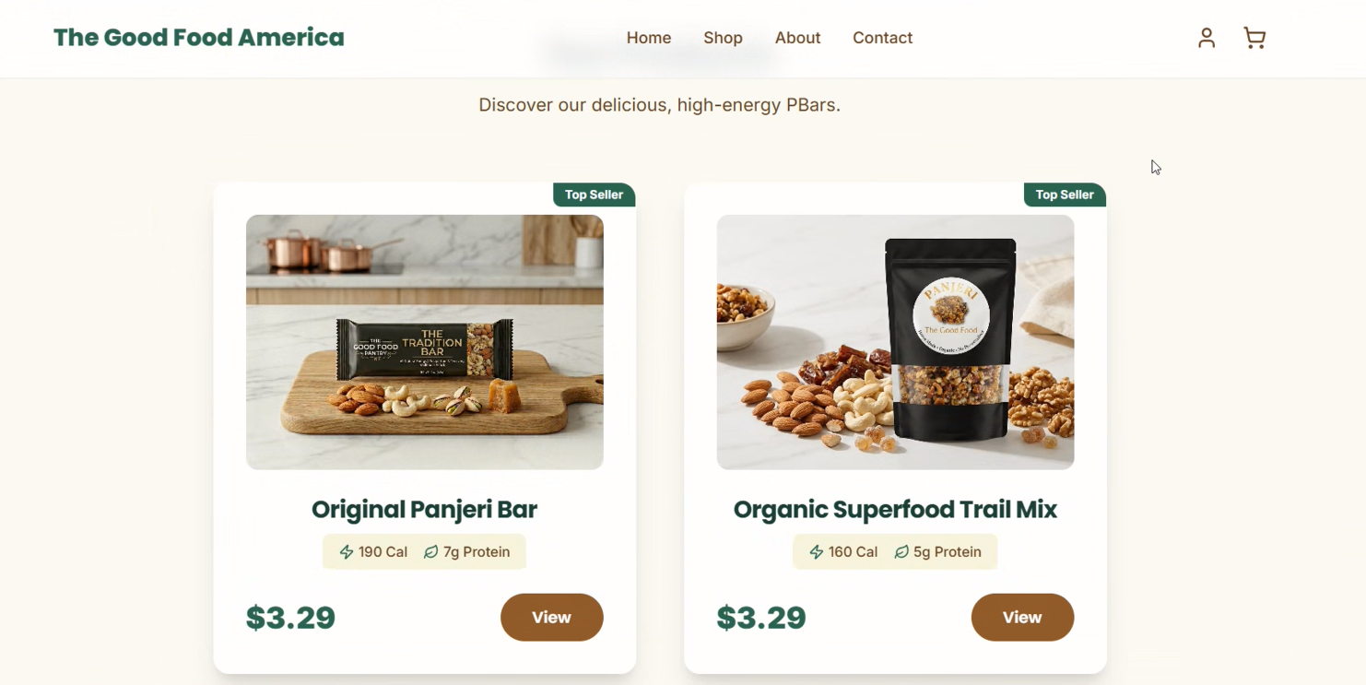
Remove the bar item. Replace with bags, one, pack of two, pack of four . (will provide calorie count and protein estimate)

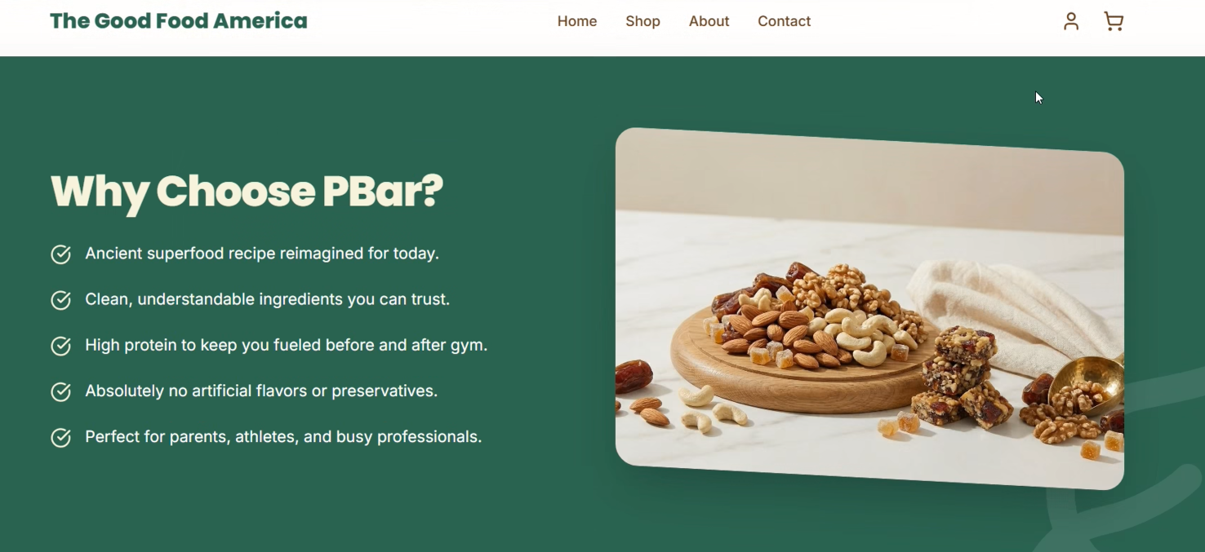
Why Choose Panjeri?
About details:
Our journey began in a simple, meaningful way—when a loving husband set out to support his wife’s recovery during the postpartum period. Wanting to nourish her with something truly wholesome, he turned to a time-honored recipe passed down from his mother: Panjeri.
Rooted in generations of wisdom, Panjeri has long been cherished for its ability to restore strength, support recovery, and provide lasting nourishment. What started as a deeply personal act of love soon became something more—a realization that this same care and nutrition could benefit many others, as this was becoming a more requested recipe from everyone who tasted and tried it.
Today, we are a family-owned business dedicated to sharing that tradition with you. We craft our Panjeri in small batches using thoughtfully selected, high-quality ingredients—staying true to the original recipe while ensuring every bite delivers warmth, comfort, and nourishment.
For us, Panjeri is more than just food. It’s a symbol of care, resilience, and the power of simple, real ingredients to support everyday wellness.
From our family to yours, we’re proud to bring you something made with purpose, tradition, and love.


Email Id : Rs 99
Contact : request form

